# Notes App

## Accessibility Issues

### Page Scan:

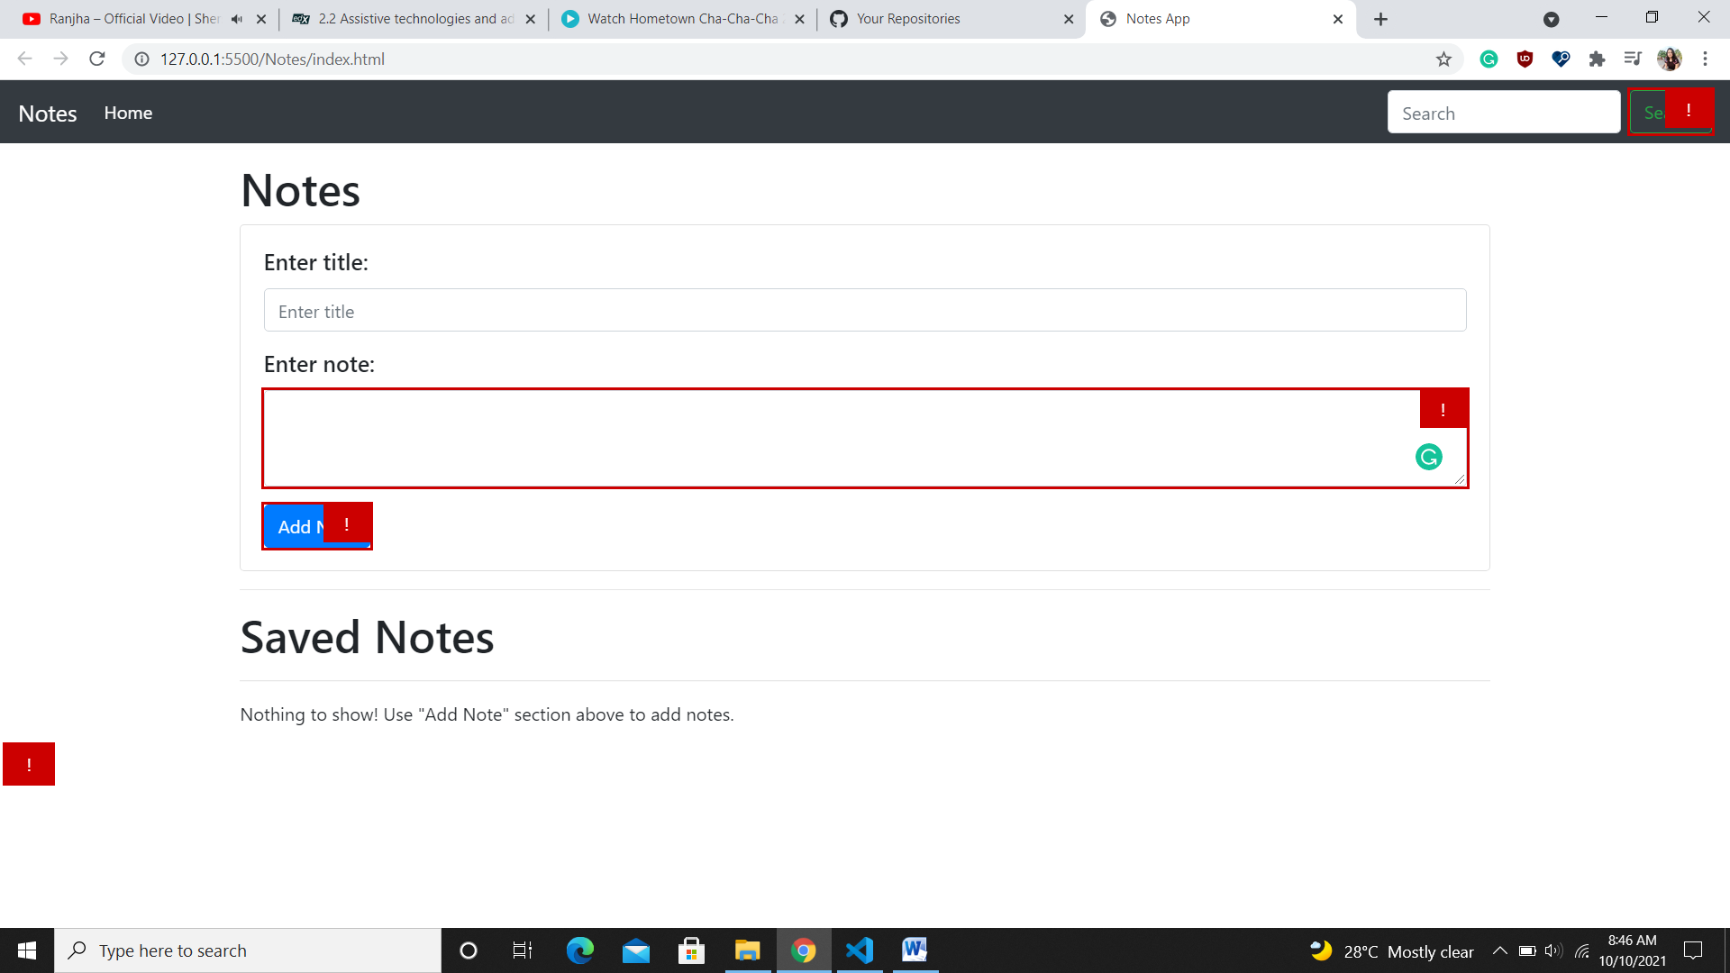

1. [color-contrast](https://accessibilityinsights.io/info-examples/web/color-contrast) -- text fails to meet the minimum required contrast against the background. – Fixed by changing the background color.
   1. Add Note button
   2. Search button
   3. Delete Note button
2. [label](https://accessibilityinsights.io/info-examples/web/label) – Enter Note text area does not have a label. – Fixed by adding aria-label.

### Non Text Contrast

1. Focus outline fails to meet the minimum required contrast ratio.

### Screen Reader

1. No label for the text area. – Fixed by adding aria-label.
2. No confirmation of Add or Delete Note.
3. No confirmation of Search.

ss